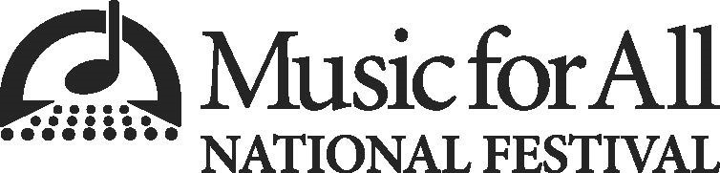

33rd Music for All National Festival

To whom it may concern,
This letter serves as verification that {NAME}, from {SCHOOL} H.S., {STATE}, will perform at the 33rd Music for All National Festival, presented by Yamaha, as part of the Honor Band of America. This national festival will take place in Indianapolis from March 25-28, 2026.
ABOUT THE FESTIVAL
From March 25-28, 2026, the Music for All National Festival will fill the city of Indianapolis with concerts from 54 ensembles representing 14 states. Both high school and middle school concert bands, orchestras, and percussion ensembles, selected following a rigorous and highly selective audition process, will grace stages across Indianapolis. Students engage in rehearsals led by some of the best music educators in the country and participate in leadership workshops. They also have the opportunity to celebrate with their fellow performers during evening receptions, socials, and banquets. Then, the honor ensemble students will close out the entire festival with their performance Saturday night.

ABOUT THE HONOR ENSEMBLES
The Music for All National Festival is home to two national ensembles, the Honor Band of America and the Jazz Band of America. The Music for All National Festival Honor Ensembles is an in-residence experience that takes place in Indianapolis from March 25-28, 2026. After only 3.5 days of rehearsal, these 104 students representing 66 schools from 29 states, perform a concert for a national audience. Both the Honor Band of America and Jazz Band of America will perform on Saturday, March 28, at 8:00 pm Eastern on the campus of Butler University in Indianapolis, IN.

The Honor Band of America has earned a national reputation as one of the nation’s finest student concert honor bands. Dr. Cynthia Johnston Turner will be at the podium as the conductor of this year’s honor band. Turner is the Dean of the Faculty of Music at Wilfrid Laurier University in Ontario, as well as the Conductor and Artistic Director of the Wellington Wind Symphony.
The Jazz Band of America has a prestigious legacy and reputation for the highest level of excellence –with opportunities to rehearse and perform with renowned conductors and world-class guest artists, premiere commissioned works, and perform for a dream audience of outstanding high school musicians and educators from across the country.
Mike Tomaro, former Jazz Studies Program Director, at Duquesne University’s Mary Pappert School of Music, will be the director of the 2026 Jazz Band of America.
Summer Camargo, member of the Saturday Night Live house band and Jazz Band of America alumna, will perform with the jazz band as the guest artist.

During the festival weekend, students participate in music education and life-skills workshops and get the opportunity to celebrate with their fellow performers during evening receptions, socials, and banquets.

If you have any additional questions, please contact Jessica Hjellming.

Jessica Hjellming
Participant Relations Manager, Music for All
festival@musicforall.org

