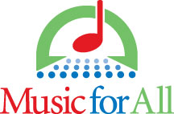

**Festival Name  
Band Evaluation Form**date & year · city, state

**Ensemble:  
Director:   
Location:**

|  |  |
| --- | --- |
| **MUSICAL ARTISTRY**  Musicianship  Interpretation  Style, Phrasing, Dynamics  Tempo, Uniformity |  |
| **TONE QUALITY**  Control  Characteristic sounds |  |
| **INTONATION**  Pitch comparison  Chords  Melodic line  Tutti |  |
| **ENSEMBLE ACCURACY**  Precision  Rhythmic Accuracy  Articulation |  |
| **BALANCE & BLEND**  Tutti ensemble  Sections of the ensemble  Soloists |  |
| **LITERATURE**  Quality  Suitability for Ensemble Variety |  |

Additional Comments:

Evaluator:___________________________________